For Immediate Release
For More Information, Contact
Kraig Troxell

Public Information Officer
Office: (703) 771-5278
Cell: (571) 436-1305
E-mail: ktroxell@loudoun.gov
04/06/07

Radio Personality Raises Communication in Loudoun County

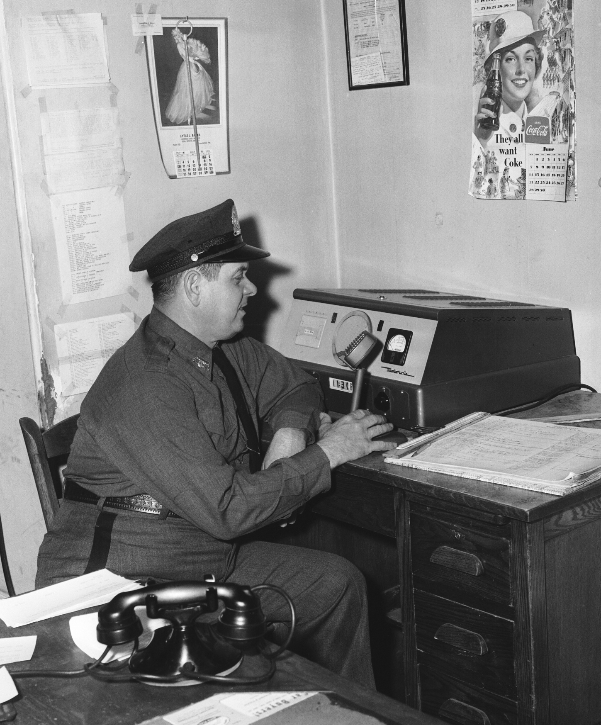
Sheriff Roger Powell Uses the Radio Equipment Donated by Arthur Godfrey.
Picture courtesy of The Winslow Williams Collection c/o The Thomas Balch Library, Leesburg, VA

The second week of April marks National Public Safety and Telecommunicators Week. The week is dedicated to the men and women who serve as public safety call takers and dispatchers.

The way public safety dispatchers communicate with Loudoun Deputies today can be traced back 50 years ago to a gift from popular radio personality, Arthur Godfrey.

In a letter dated November 22, 1952, Roger F. Powell, who served as Loudoun’s Sheriff from 1952 to 1959, informed then County Chairman I.W. Baker that Arthur Godfrey had donated $2000 “to be used in installing a county police radio communication system.” The revelation of Godfrey’s name was controversial at the time as the radio personality had asked for his contribution to remain anonymous. Sheriff Powell was forced to release the radio stars name after some supervisors declared there would be no budget increase requests for the Sheriff unless the identity of the donor was revealed. “No money for an extra man until you talk,” the board demanded according to one local newspaper.

Godfrey, who started his radio career in Baltimore in 1929, later joined Washington D.C.’s NBC affiliate. In 1942 his morning show could be heard on CBS’ flagship station, WABC in New York. Back in Loudoun County, Godfrey purchased the Beacon Hill Estate west of Leesburg, Virginia and commuted by plane from his farm to studios in New York City every Sunday night. Godfrey would affectionately refer to his land as ‘the old cow pasture’ on his radio show.

In the revelation letter to the Board of Supervisors, Sheriff Powell stated that he discussed with Godfrey issues within the Sheriff’s Office and the fact that two county tragedies had recently taken place: a robbery and shooting in Hillsboro and the Fox family murders. Powell told Godfrey that he would like to have a county police system “whereby all the emergency units, such as fire departments, rescue squads, and the game warden could be tied together as more efficient operating units”. Mr. Godfrey asked, “What will it cost?”

According to the letter, initial estimates for the radio system were in the range of $1200. In response to the figure Godfrey said, “one thousand or two thousand dollars, get busy, don’t let any moss grow on it. I’ll do that much for my people of Loudoun County.” The cost rose to $1600 before Godfrey donated a total of $2000 stating “we don’t want any dead spots in the system; (get) the kind of equipment that will do the job right.” Less than a month later on December 18, 1952, a headline in the Loudoun News proclaimed “Loudoun County Police Radio Station Goes On Air Today”.

Only a few years later, Godfrey continued his good will with the donation of a small portion of his land off of Old Waterford Road near Leesburg. The land was used by the Loudoun Sheriff’s Office to build a radio tower; greatly increasing the agency’s communications capabilities. Robert W. Legard, who served as Loudoun County Sheriff from 1964 to 1979, worked with Hankey’s Radio in Frederick, MD to erect a tower on the land. The tower broadcasted two low-band channels, one for the Sheriff’s Office and one for Loudoun Fire/Rescue. The tower still stands today but is no longer in use.

For several decades, Sheriff’s Offices across the state used the low-band frequency of 39.5 megacycles, which caused problems on busy weekends. On some evenings, Fauquier County, VA deputies and Loudoun deputies would compete for airtime when responding to calls. Because of the nature of low-band frequencies, which can skip great distances off of the atmosphere on clear nights, the radios would pick up radio traffic from law enforcement as far away as Bogalusa, Louisiana.

For nearly 40 years the dispatching system broadcast from the county jail on Church Street in Leesburg. In 1990 the needs of the Sheriff’s Office dispatch center outgrew the facility and moved to its current location on Courage Court. The dispatch office, today referred to as the Emergency Communications Center (ECC), employs over 40 dispatchers. In 2006, the staff handled over 390,000 9-1-1 and non-emergency calls.

In 2000 and after years of requests, current Loudoun County Sheriff Steve Simpson secured funding for Loudoun’s public safety community to finally upgrade to an 800 MHZ digital trunking system. The 11-channel system allows separate simultaneous channels for the agency’s specialty units and covers the entire county with few drop-out areas. A few years later Sheriff’s patrol cars were outfitted with mobile data terminals allowing deputies to turn in paperless reports from the front seat of their vehicles.

Godfrey was instrumental in the implementation of the public safety radio system in Loudoun County, but his good will did not end with the Sheriff’s Office. Over the years Godfrey donated an ambulance and the financing for an entire wing for Loudoun County Hospital. In 1960 Godfrey donated $200,000 from the sale of his 'old cow pasture' for the development of an airport. The area is now known as Leesburg Executive Airport at Godfrey Field.

Arthur Godfrey passed away in New York in 1983 and is buried in Union Cemetery only a few miles from his former Leesburg home.

The Loudoun County Sheriff’s Office was founded in 1757 and is currently celebrating their 250th anniversary.

